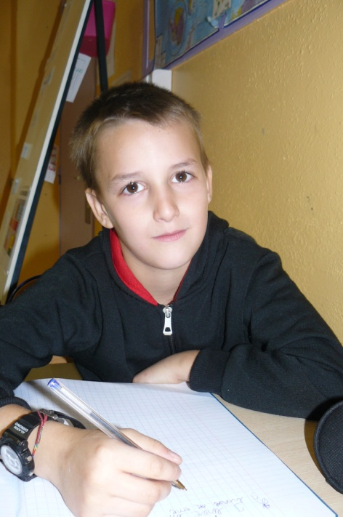
Hello!
My name is Enzo.
I’m 7 years old.
I live in Vichy, in France.
I have 4 sisters and 2 brothers.
I have one cat but no dog and no rabbit.
I like sports.
I don’t like spinaches.

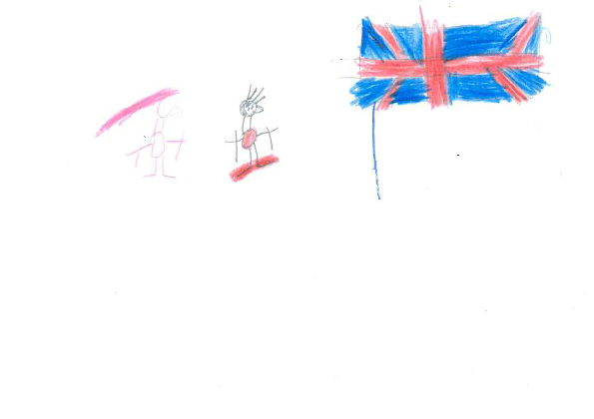

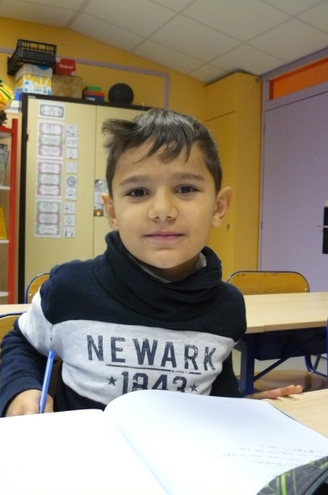
Hello!
My name is Mohamed-Reda.
I’m 7 years old.
I live in Vichy, in France.
I have no sister and one brother.
I have no dog and no cat and no rabbit.
I like school.
I don’t like Violetta.

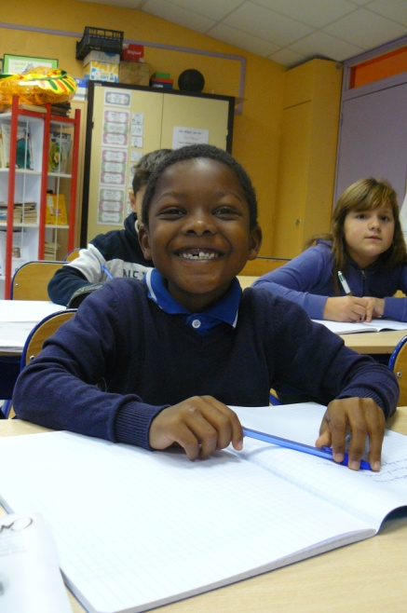
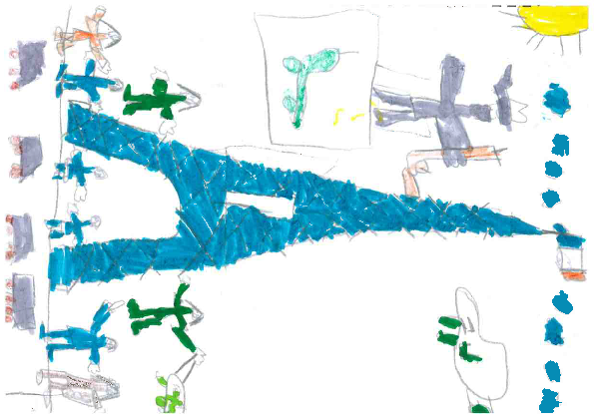
Hello!
My name is Owen.
I’m 7 years old.
I live in Vichy, in France.
I have one sister and no brother.
I have no dog and no cat and no rabbit.
I love my little sister.
I don’t like doing my homework.

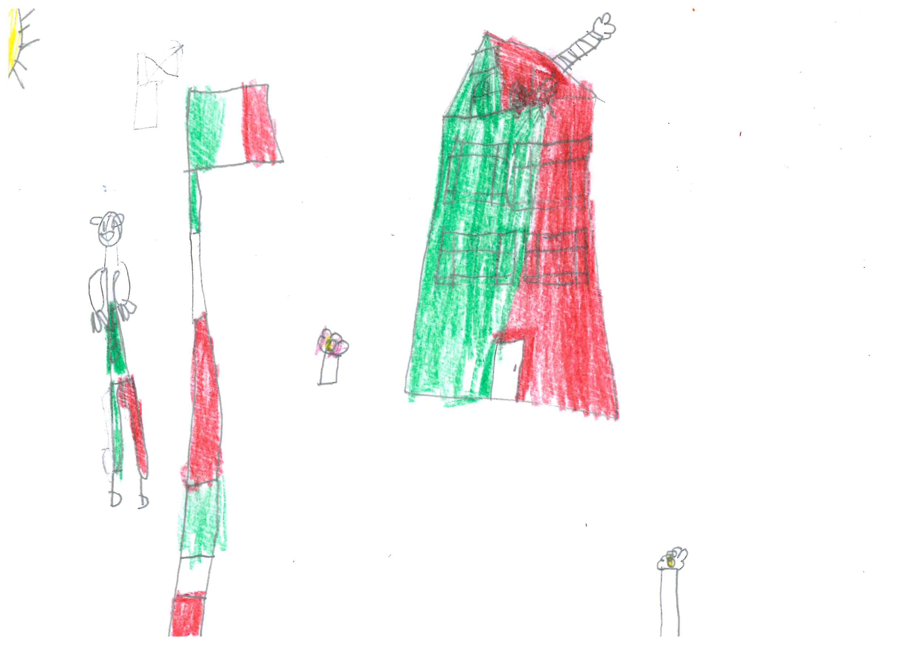
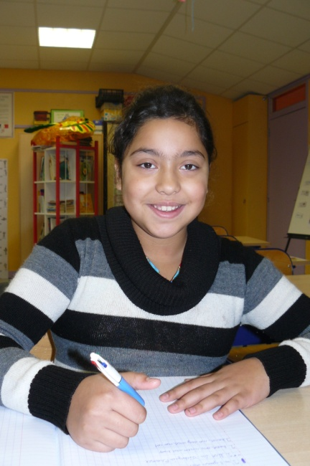
Hello!
My name is Fatima.
I’m 8 years old.
I live in Vichy, in France.
I have one sister and two brothers.
I have no dog and no cat and no rabbit.
I like dogs.
I don’t like raviolis.
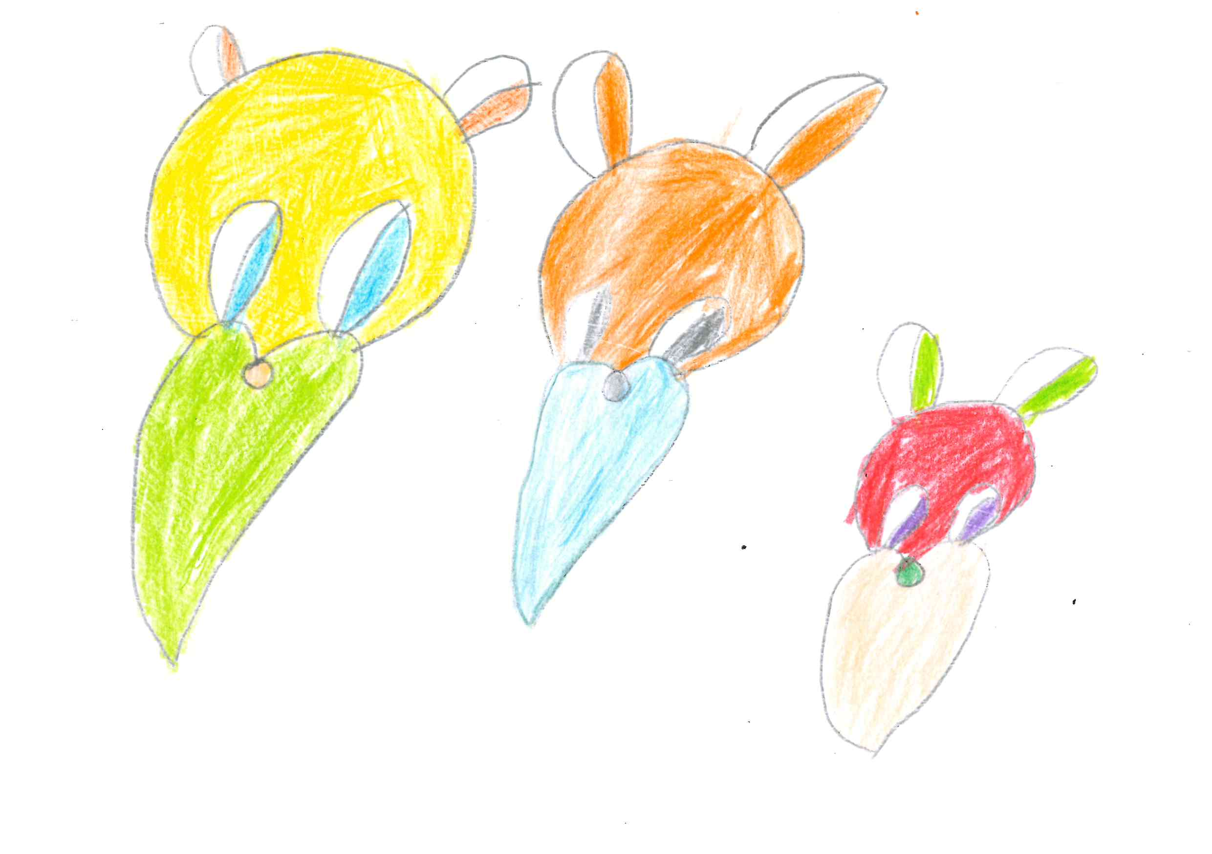
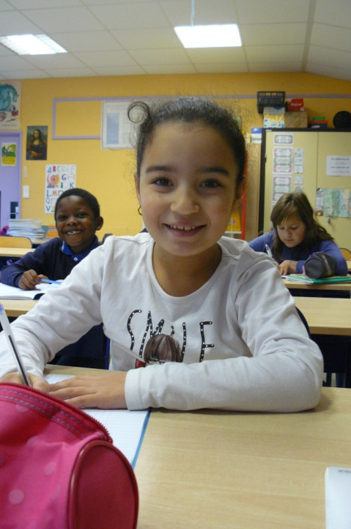
Hello!
My name is Nihad.
I’m 7 years old.
I live in Vichy, in France.
I have no sister and no brother.
I have one cat but no dog and no rabbit.
I love my cat.
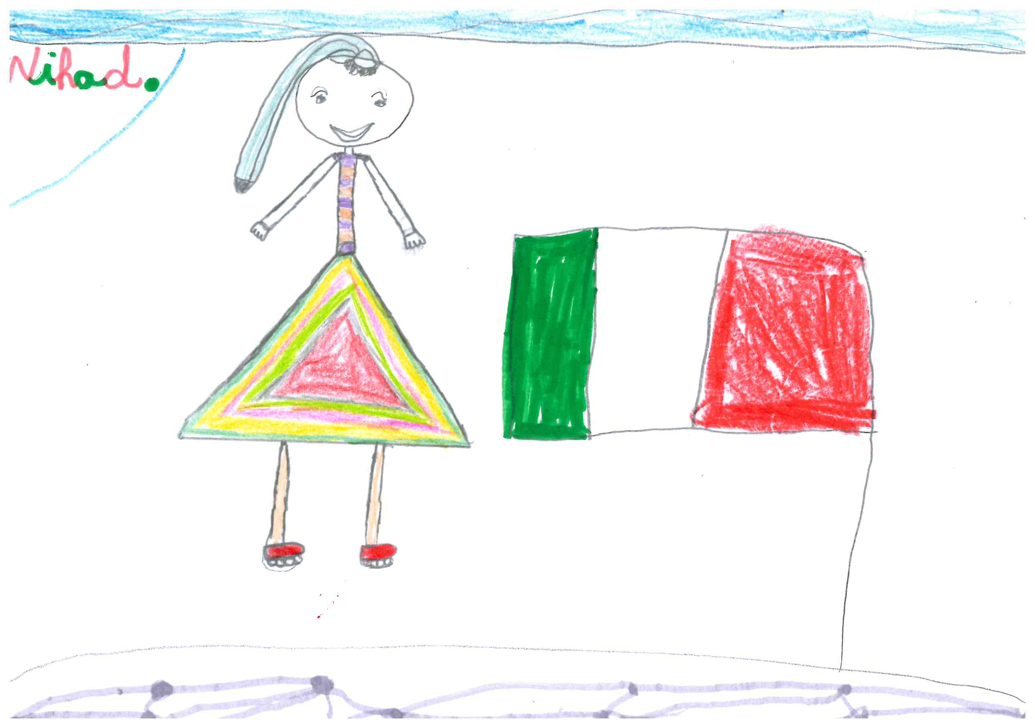
I don’t like being alone.
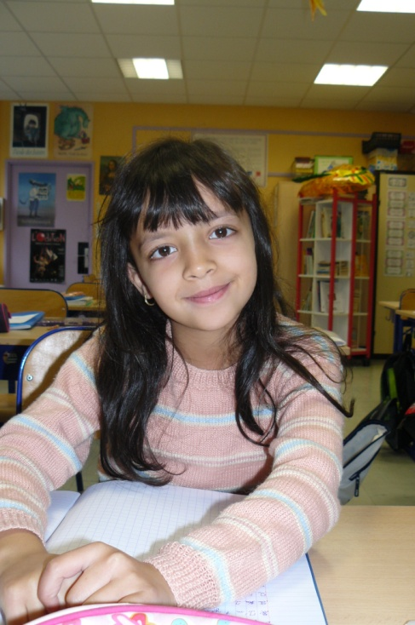
Hello!
My name is Yousra.
I’m 7 years old.
I live in Vichy, in France.
I have no sister and one brother.
I have no dog and no cat and no rabbit.
I like school.
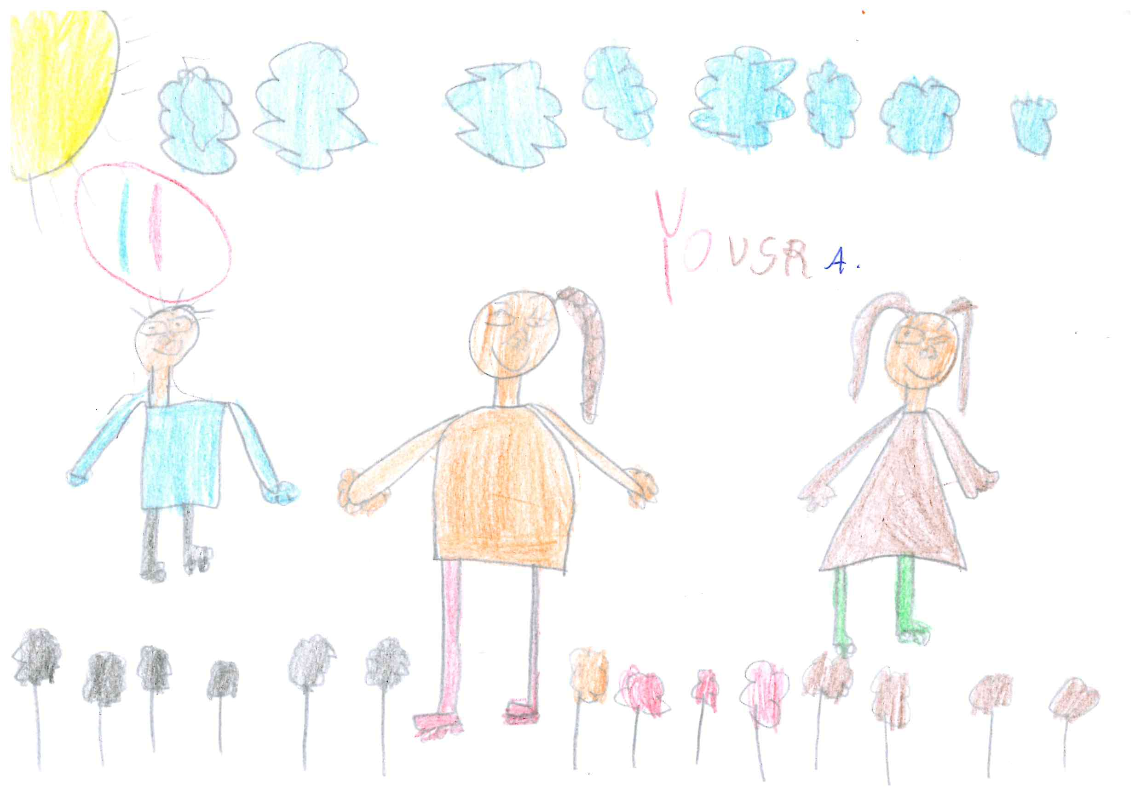
I don’t like spinaches.
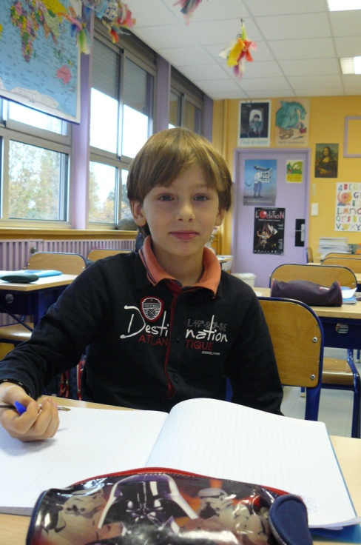
Hello!
My name is Moussa.
I’m 7 years old.
I live in Vichy, in France.
I have two sisters and one brother.
I have one cat but no dog and no rabbit.
I like cats.
I don’t like spinaches and fishes.
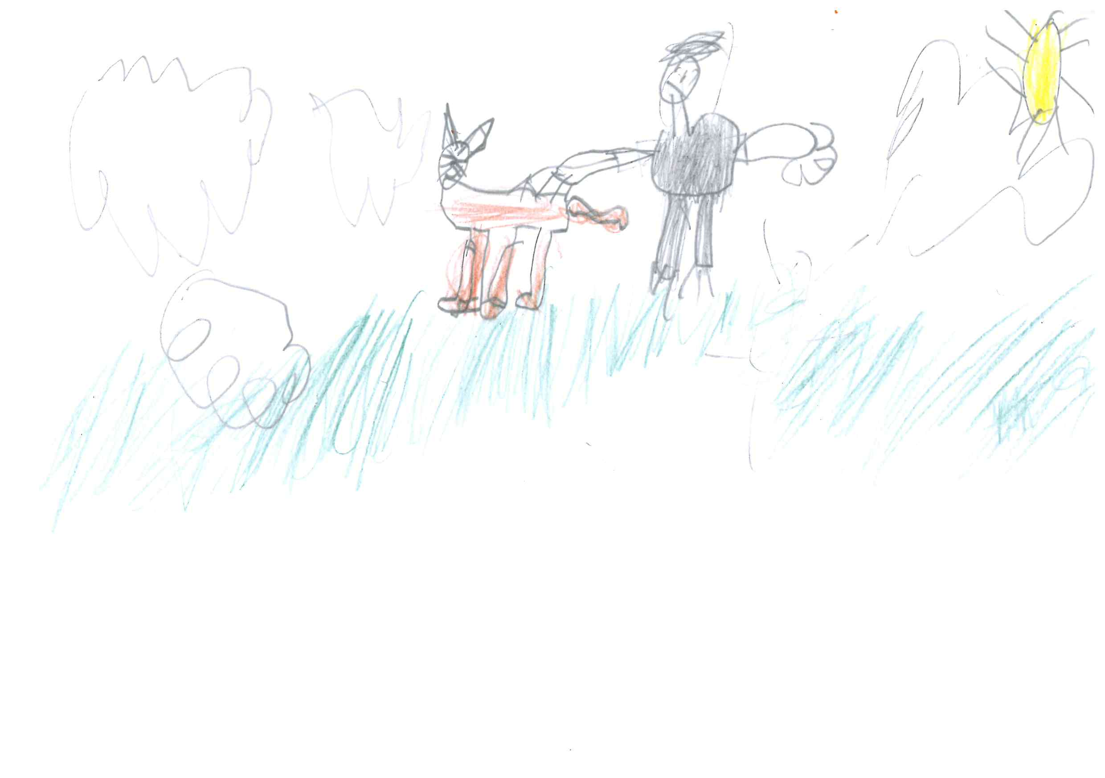
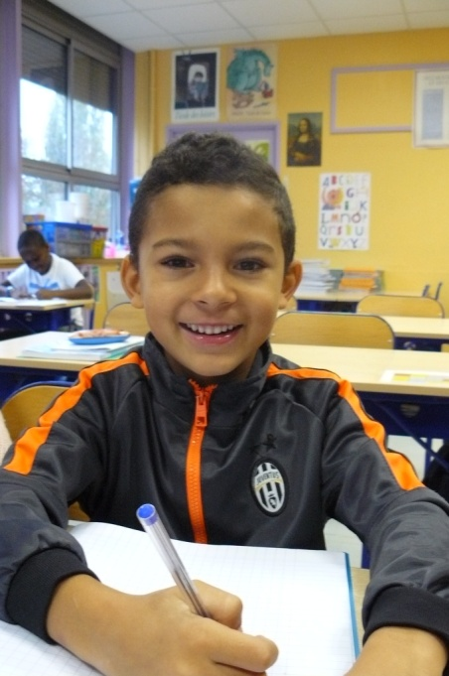
Hello!
My name is Noham.
I’m 7 years old.
I live in Vichy, in France.
I have no sister and no brother.
I have no dog and no cat and no rabbit.
I like cooking cakes.
I don’t like broccolis and spinaches.

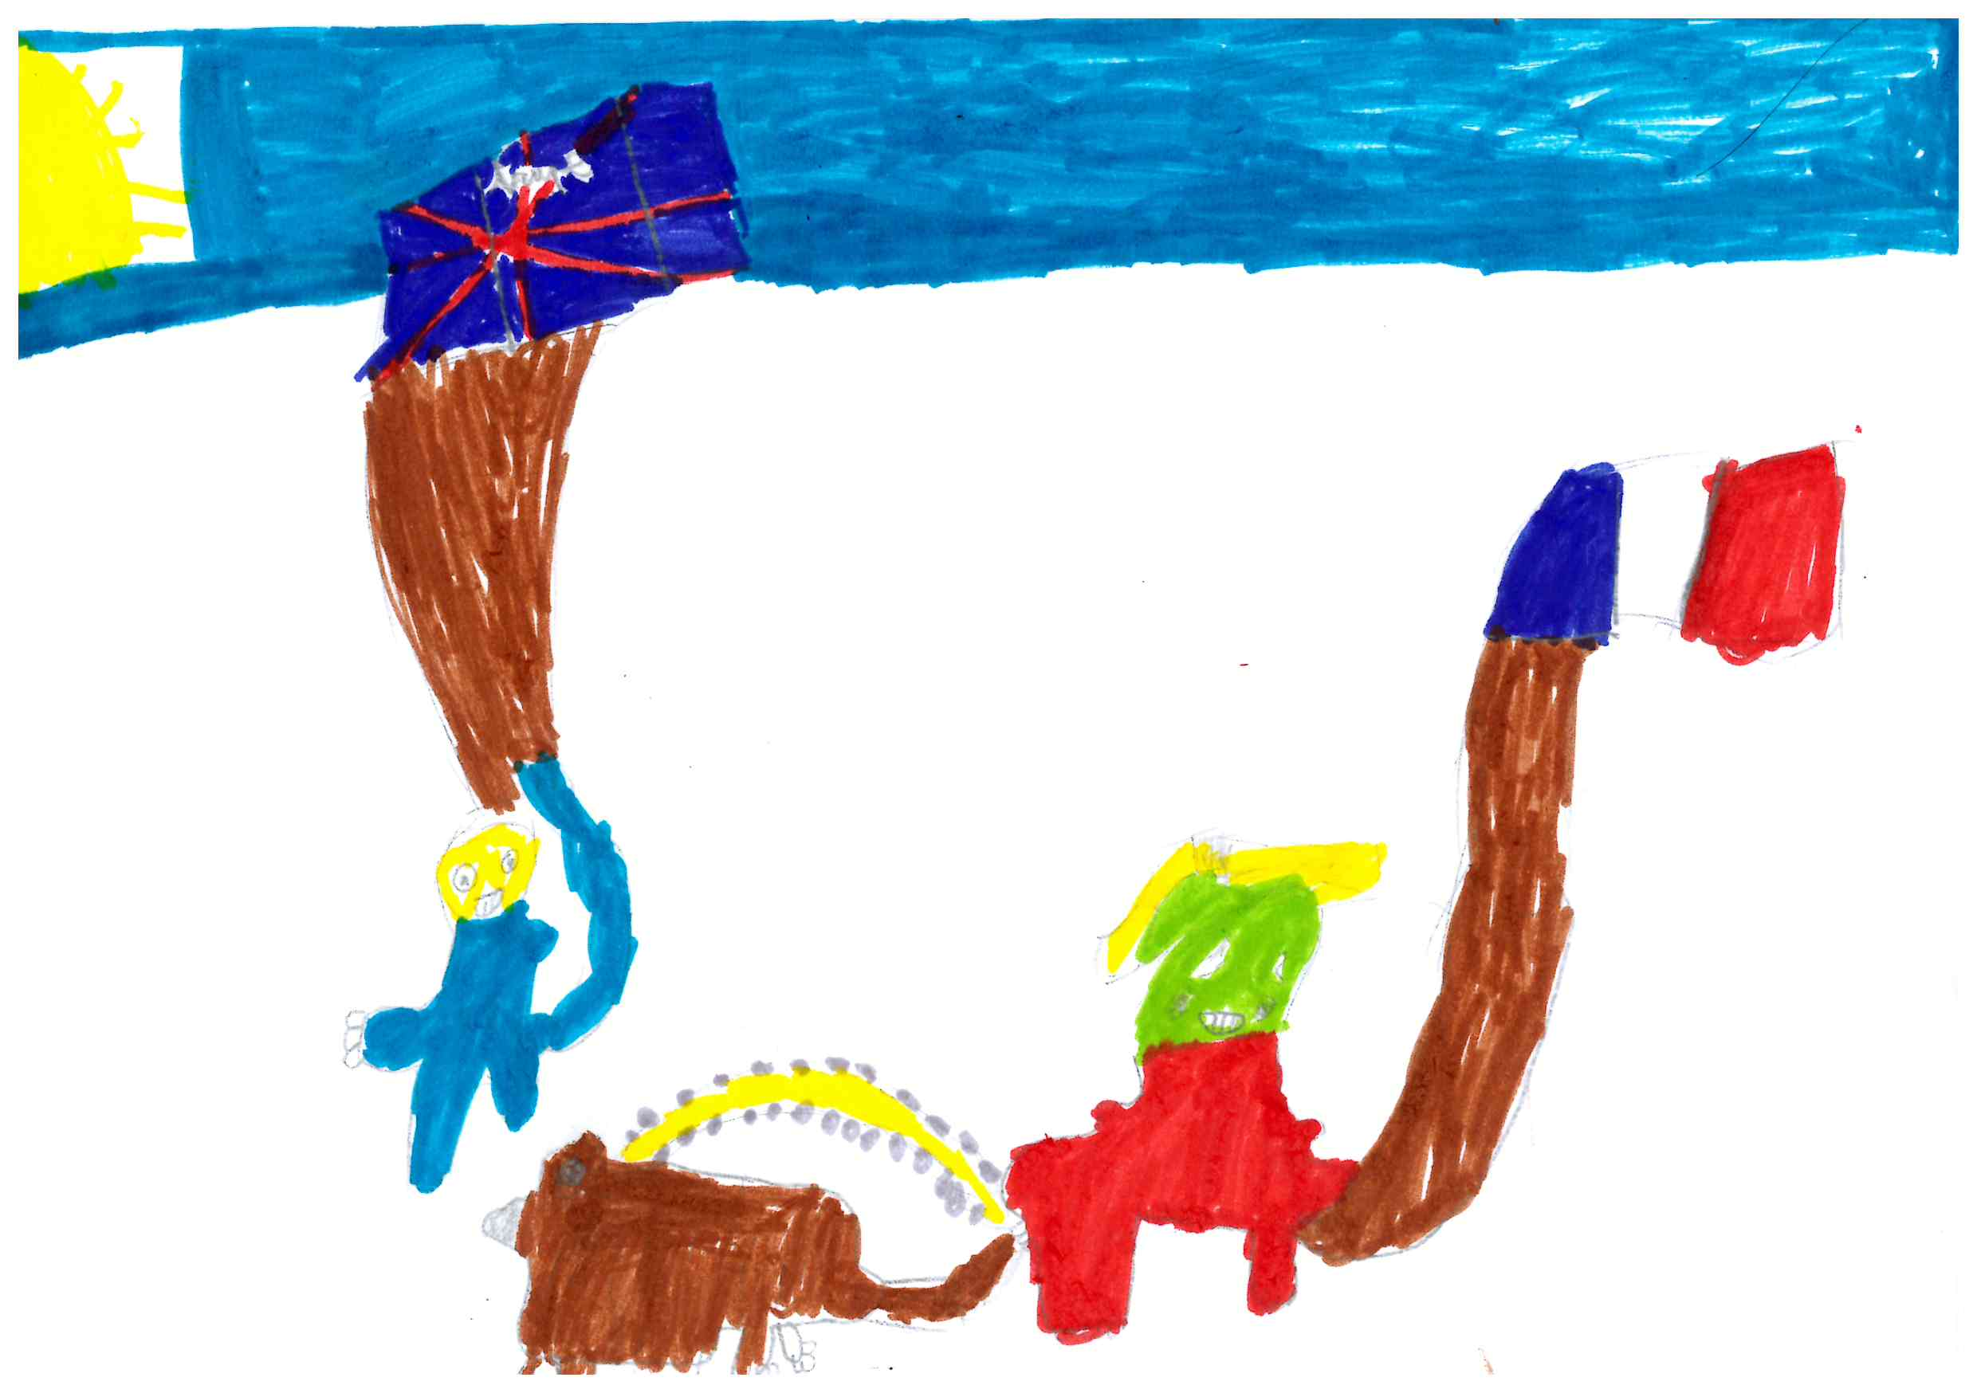
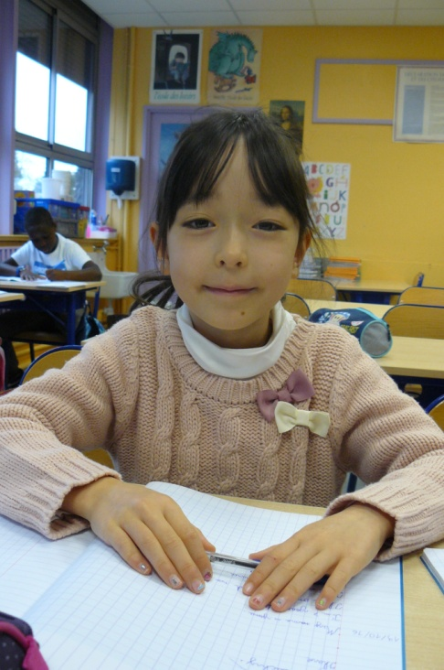
Hello!
My name is Yuna.
I’m 7 years old.
I live in Vichy, in France.
I have one sister and no brother.
I have one dog but no cat and no rabbit.
I like drawing.
I don’t like spinaches.

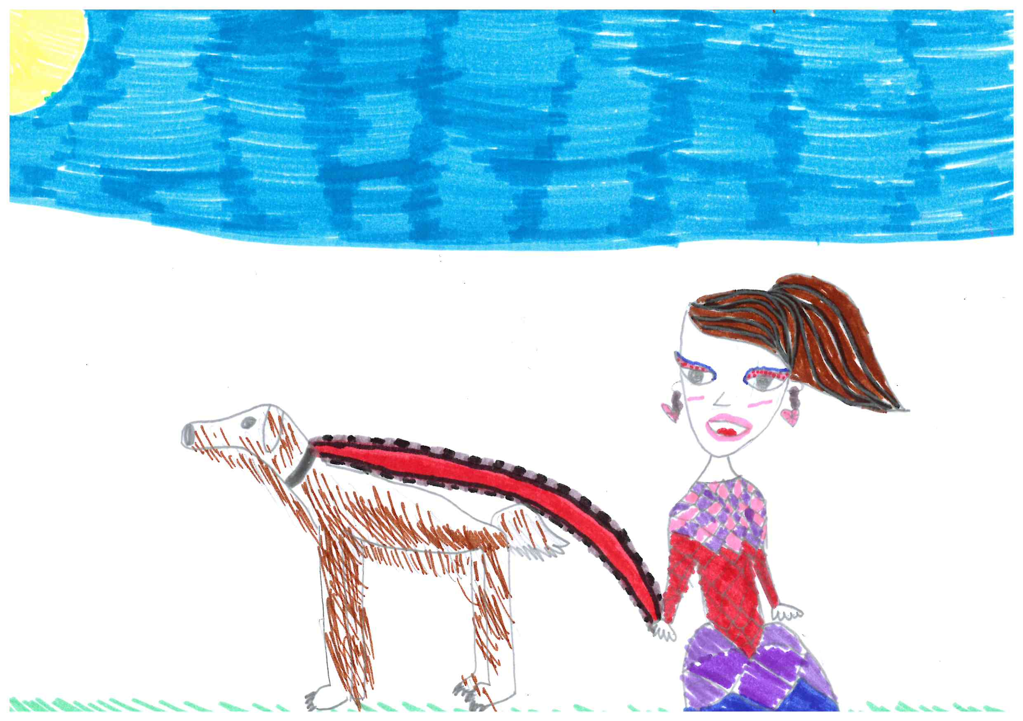
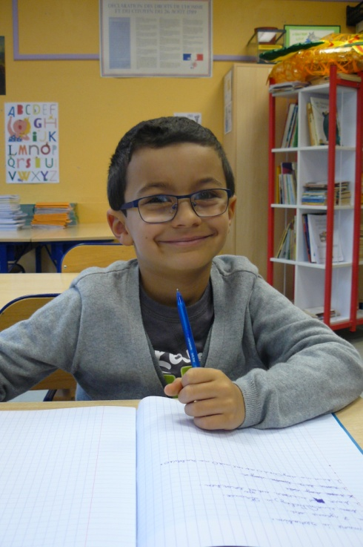
Hello!
My name is Ibrahim.
I’m 7 years old.
I live in Vichy, in France.
I have no sister and one brother.
I have no dog and no cat and no rabbit.
I like playing on my digital tablet.
I don’t like eating salad.

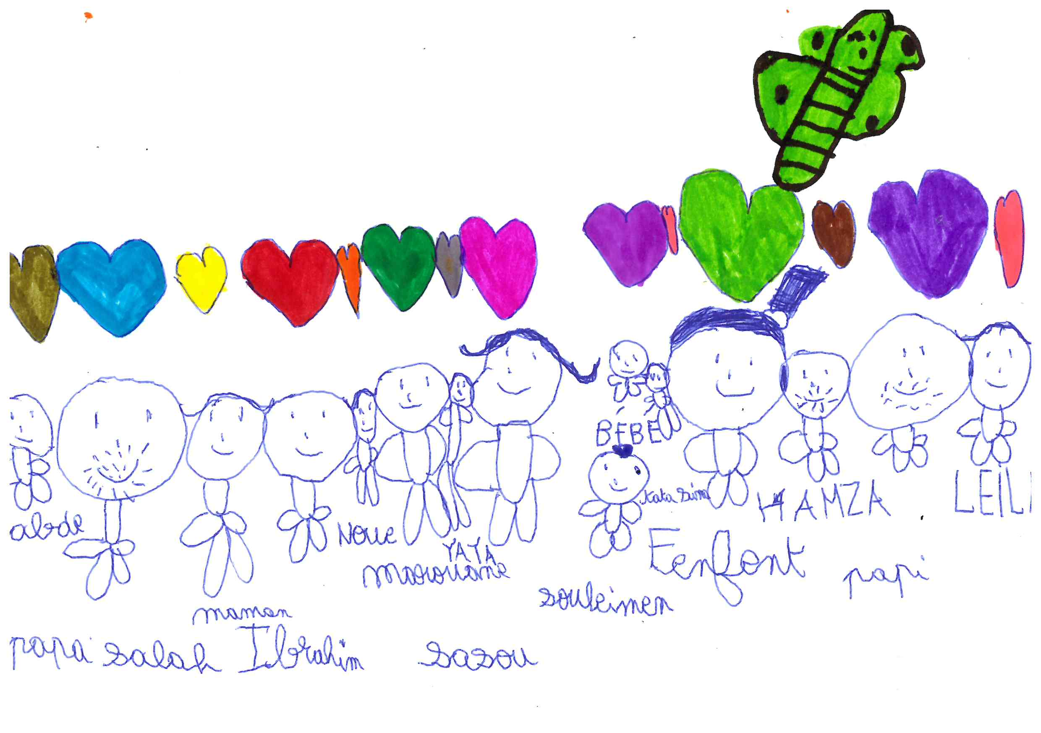
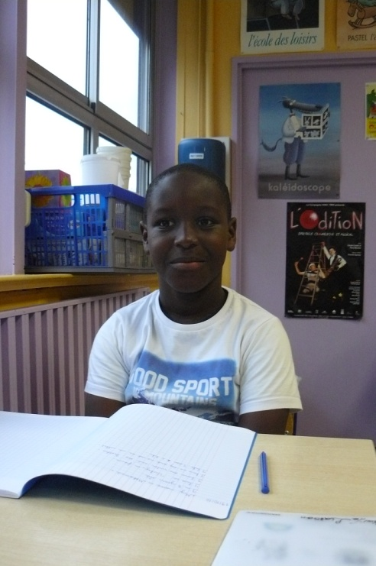
Hello!
My name is Mohamed.
I’m 8 years old.
I live in Vichy, in France.
I have one sister and one brother.
I have no dog and no cat and no rabbit.
I like writing.
I don’t like Chica Vampiro.

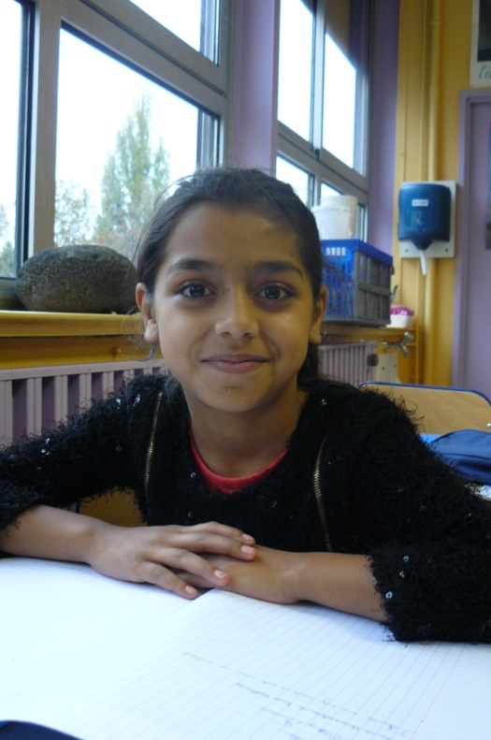
Hello!
My name is Sabrina.
I’m 7 years old.
I live in Vichy, in France.
I have three sisters and two brothers.
I have no dog and no cat and no rabbit.
I like playing.
I don’t like sports.

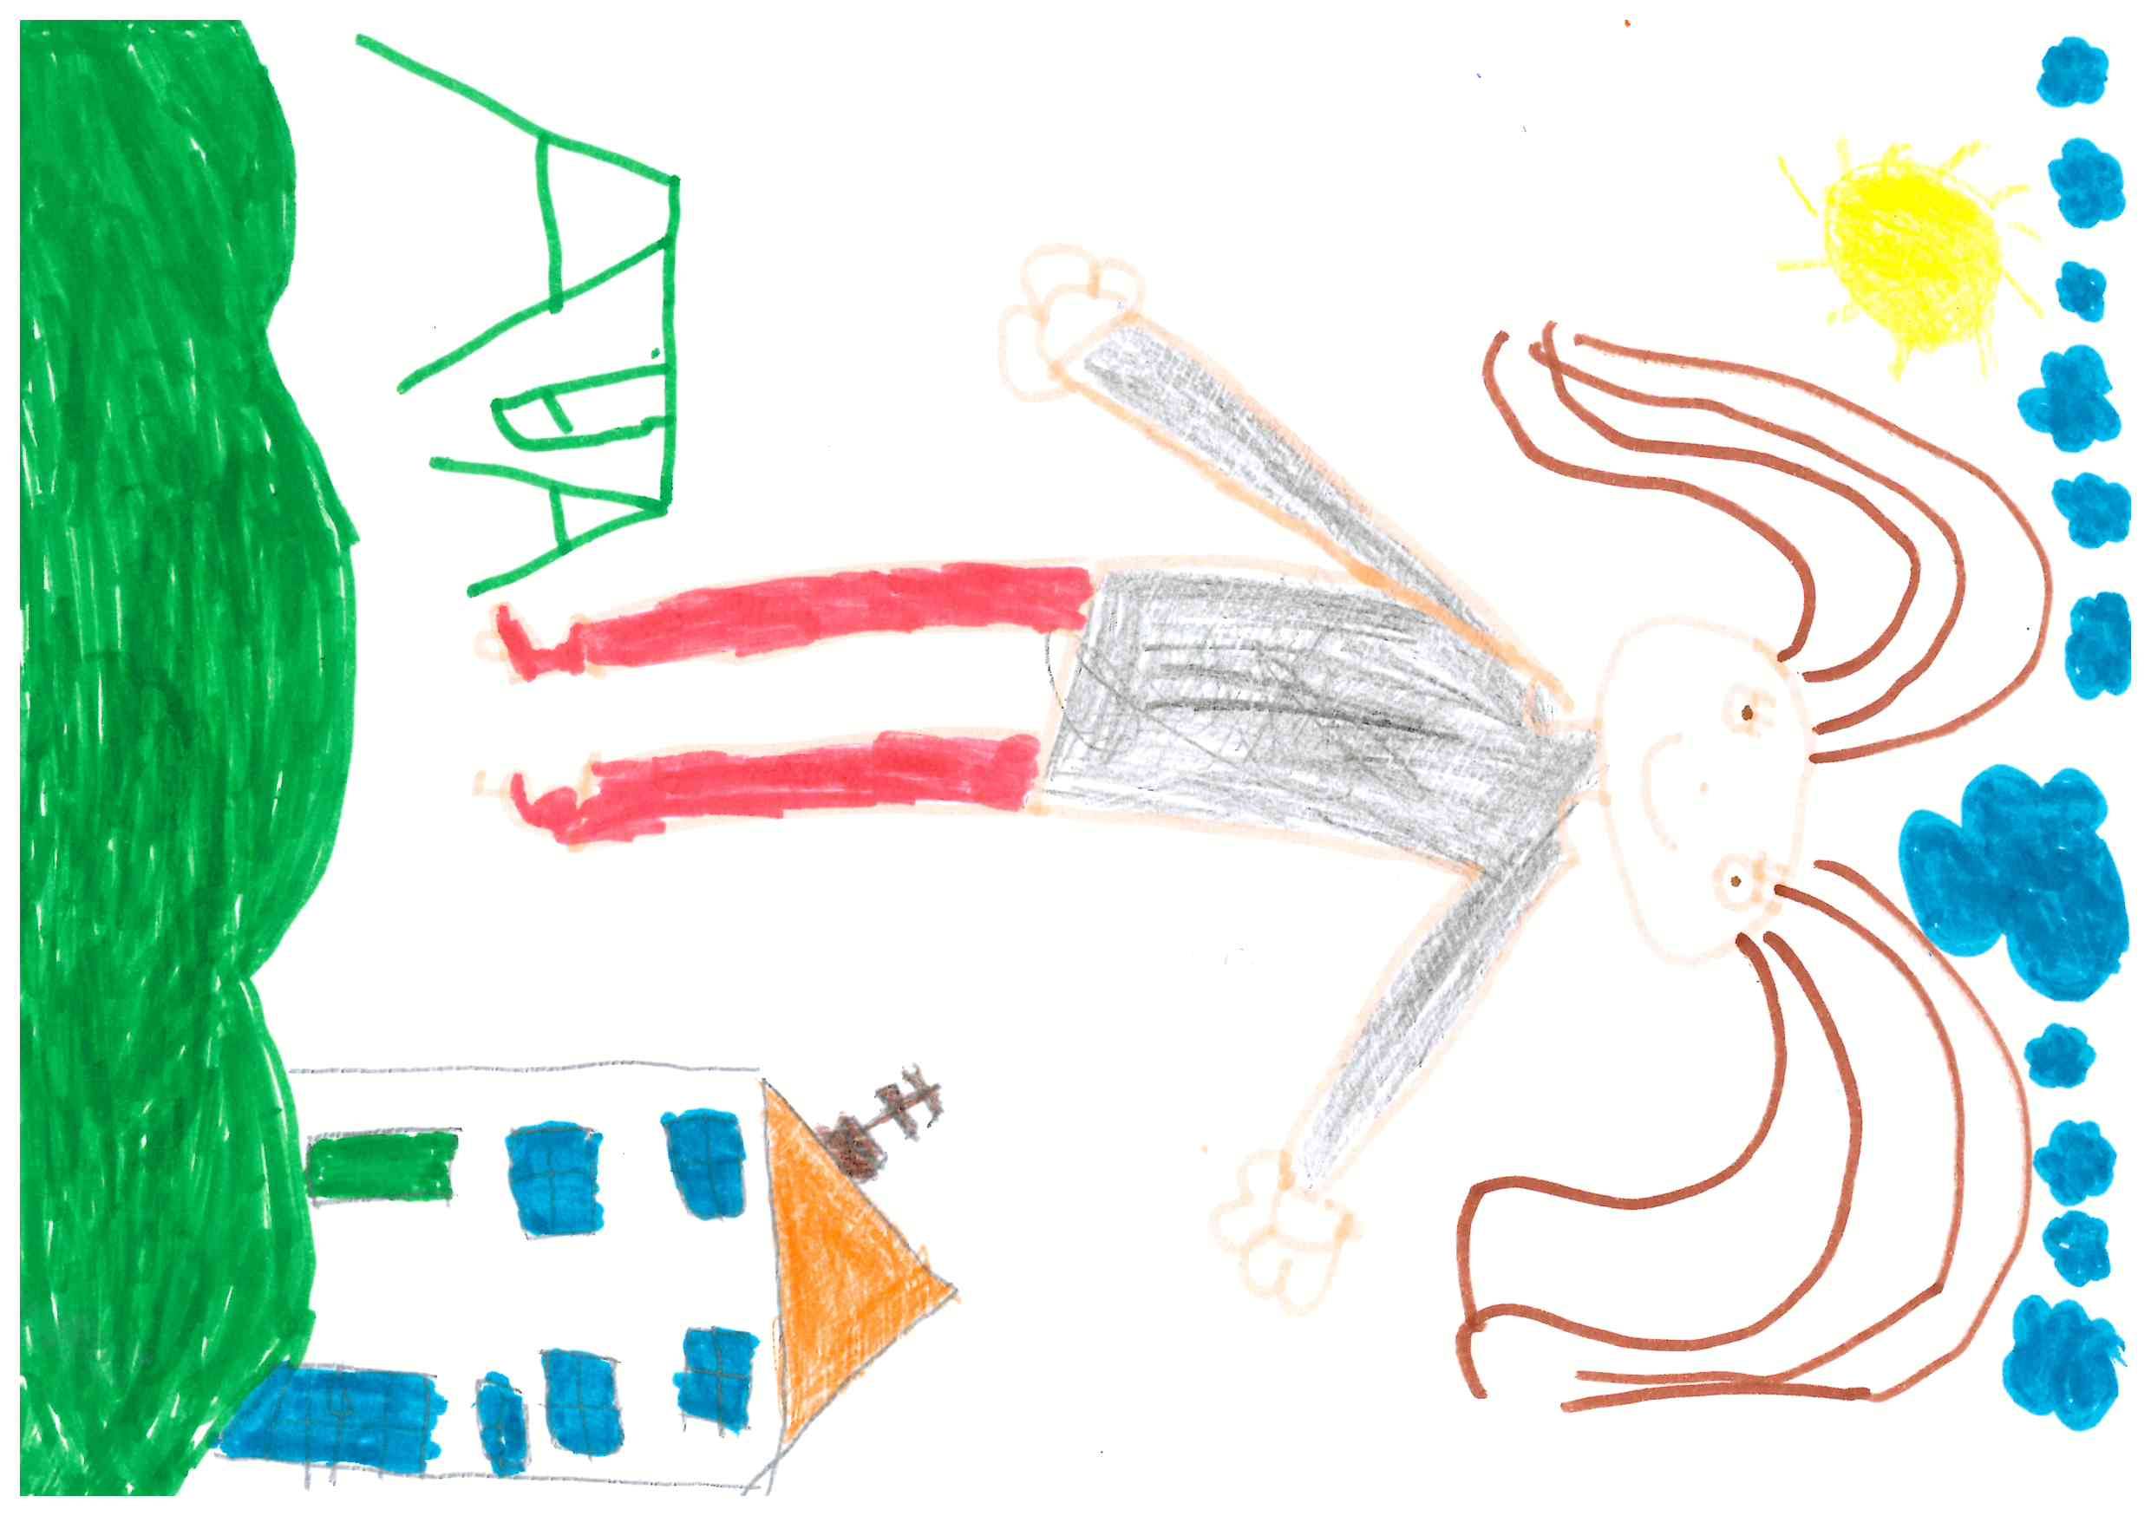
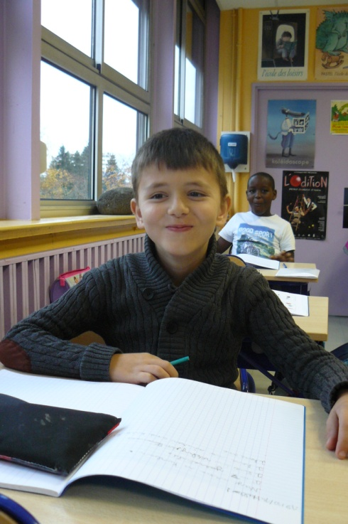
Hello!
My name is Kurban.
I’m 7 years old.
I live in Vichy, in France.
I have no sister and two brothers.
I have one rabbit but no dog and no cat.
I love my rabbit.
I don’t like doing my homework.

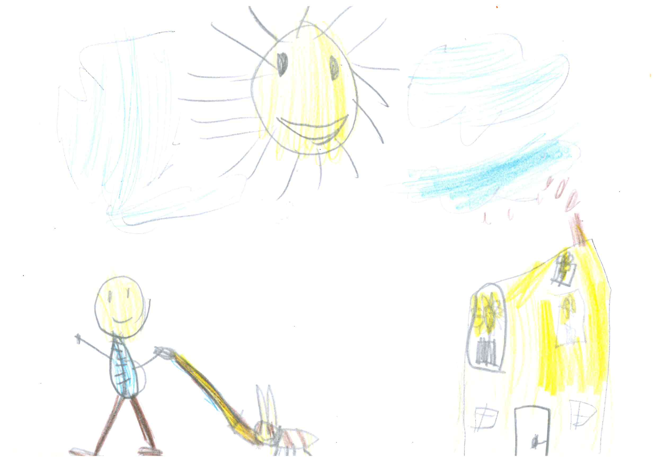
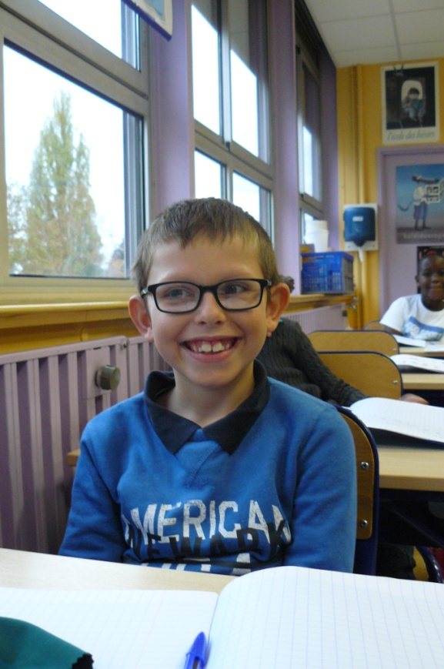
Hello!
My name is Dylan.
I’m 8 years old.
I live in Vichy, in France.
I have two sisters and no brother.
I have one dog but no cat and no rabbit.
I like dogs.
I don’t like eating mutton and Barbie dolls.

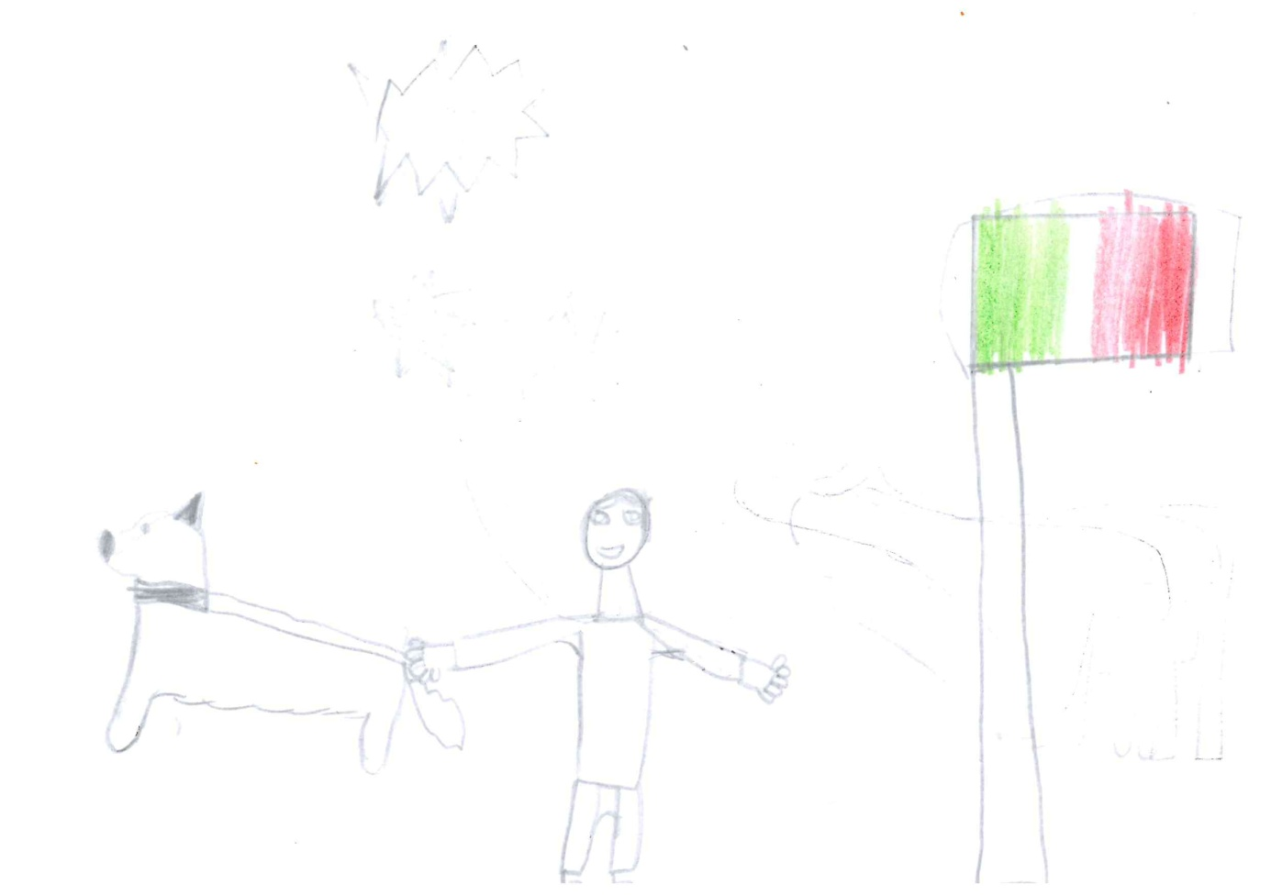
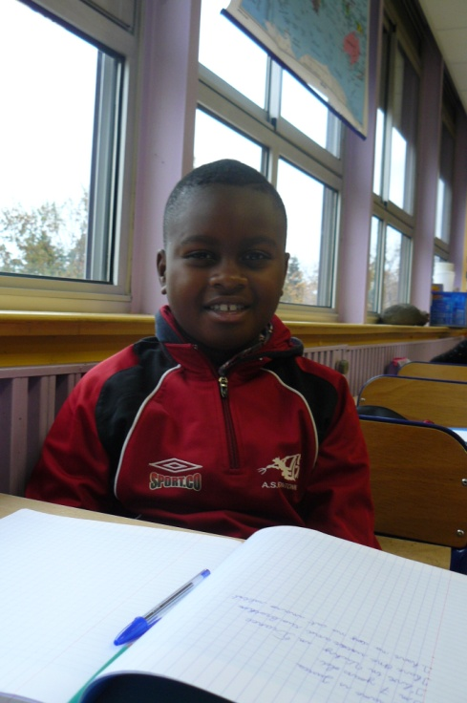
Hello!
My name is Justice.
I’m 7 years old.
I live in Vichy, in France.
I have one sister and two brothers.
I have no dog and no cat and no rabbit.
I like sports.
I don’t like cats.

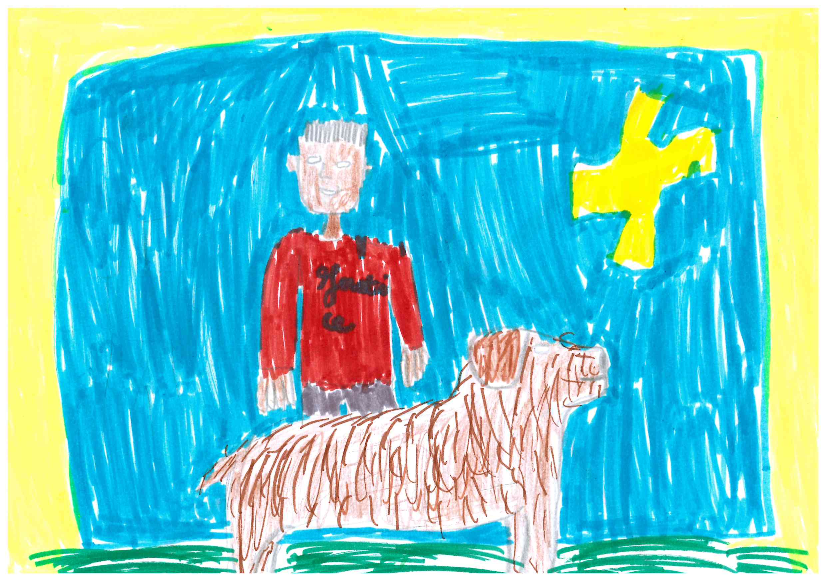
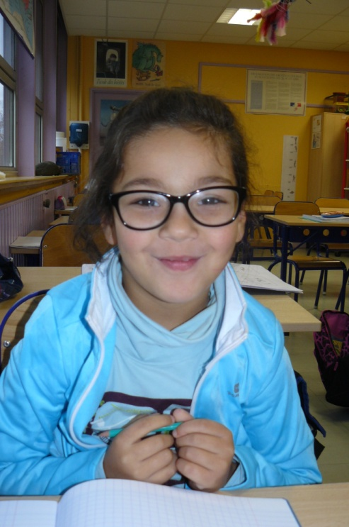
Hello!
My name is Souad.
I’m 7 years old.
I live in Vichy, in France.
I have no sister and two brothers.
I have one cat but no dog and no rabbit.
I like doing pottery.
I don’t like being alone.

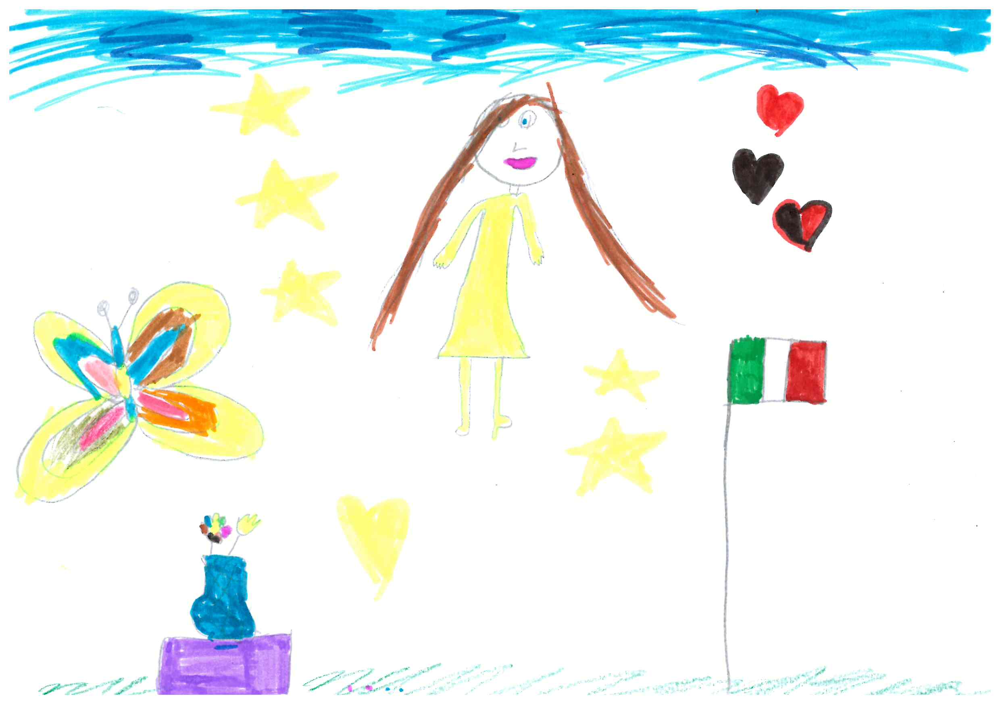
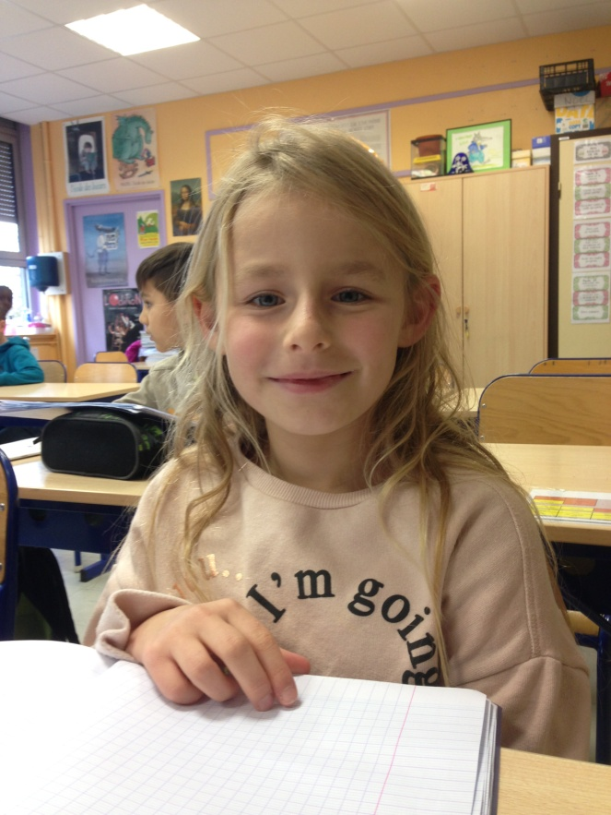
Hello!
My name is Zoé.
I’m 7 years old.
I live in Vichy, in France.
I have no sister and one brother.
I have one cat but no dog and no rabbit.
I like playing football and going to school.
I don’t like fighting.

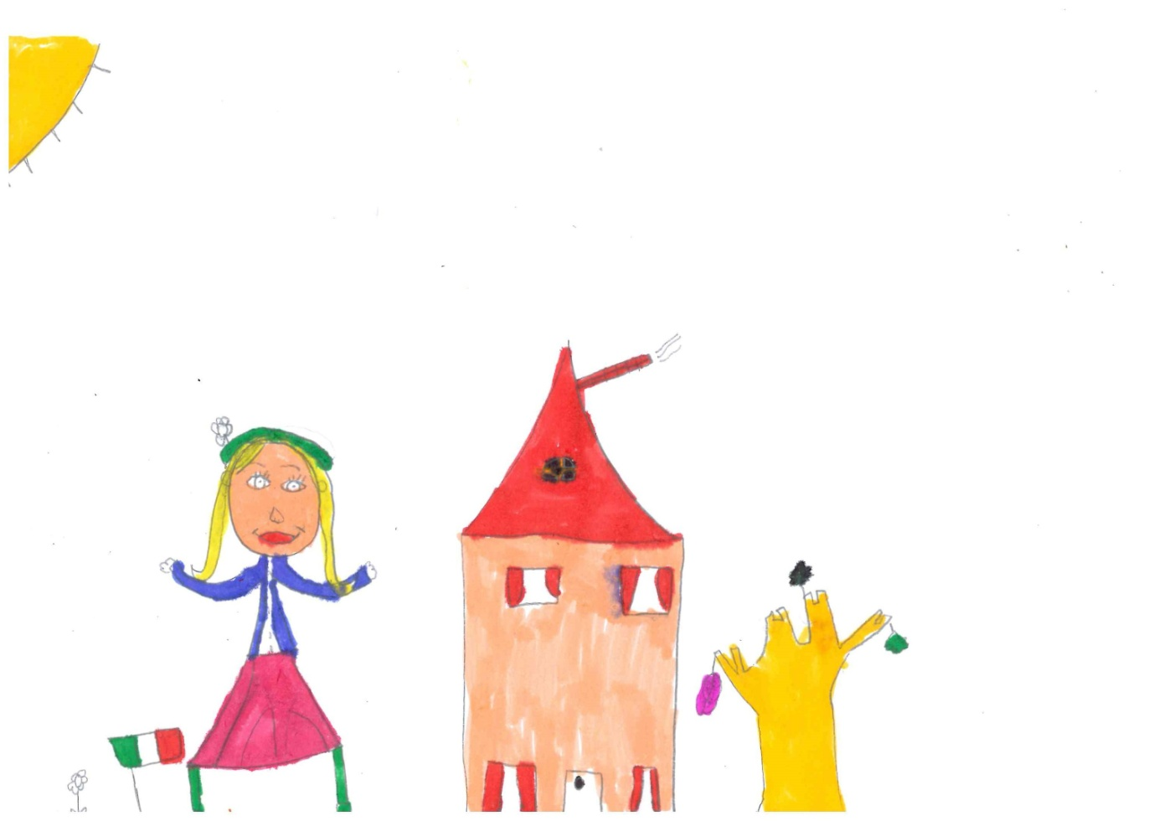
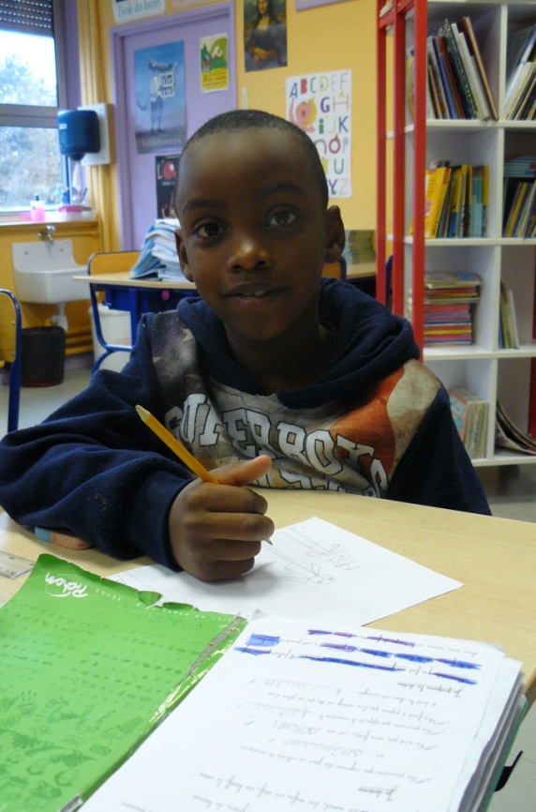
Hello!
My name is Nafez.
I’m 7 years old.
I live in Vichy, in France.
I have no sister but two brothers.
I have no dog and no cat and no rabbit.
I like sports.
I don’t like eating pork.

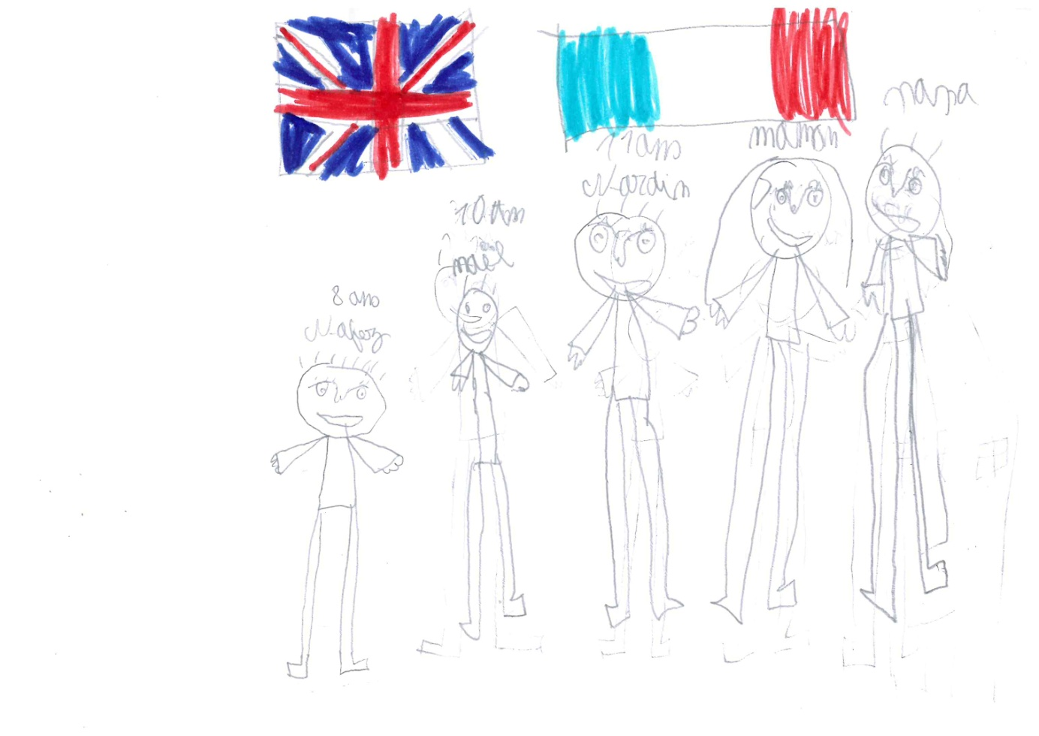
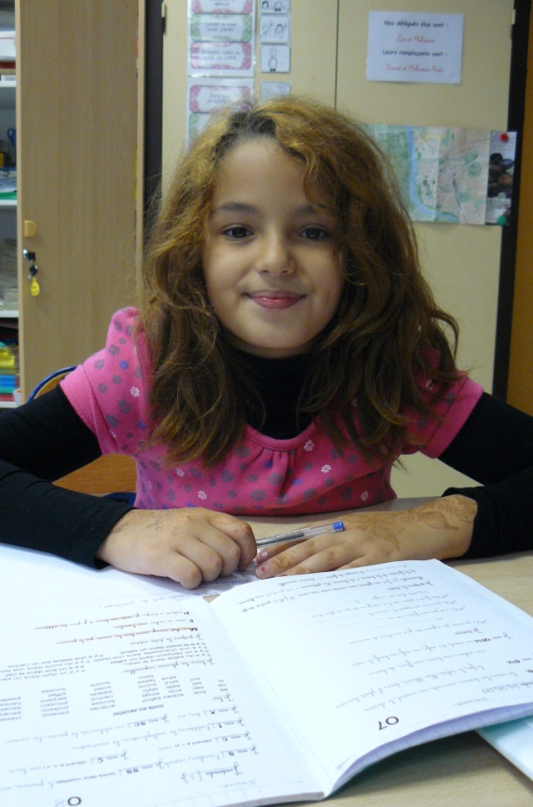
Hello!
My name is Imane.
I’m 8 years old.
I live in Vichy, in France.
I have two sisters and one brother.
I have no dog and no cat and no rabbit.
I like my friends.
I don’t like fighting.

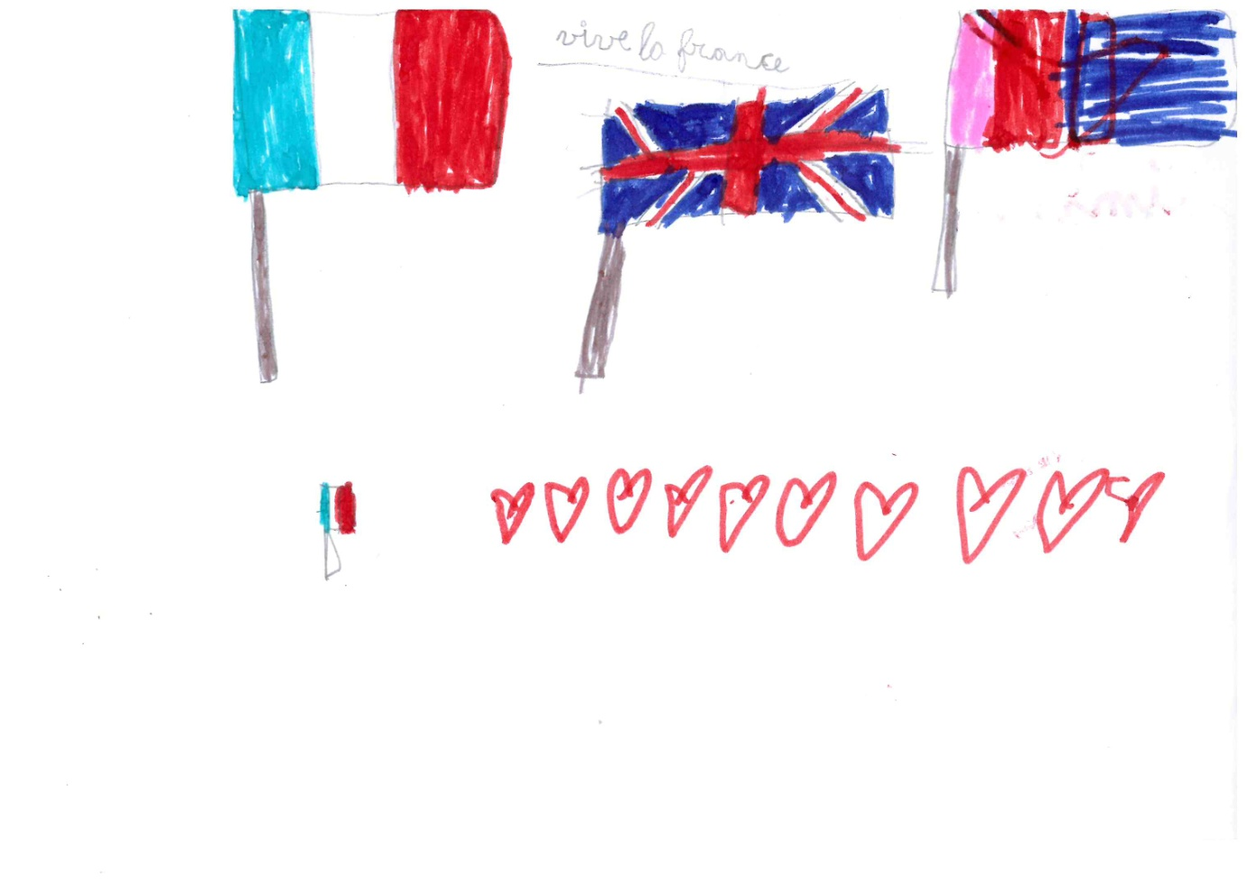
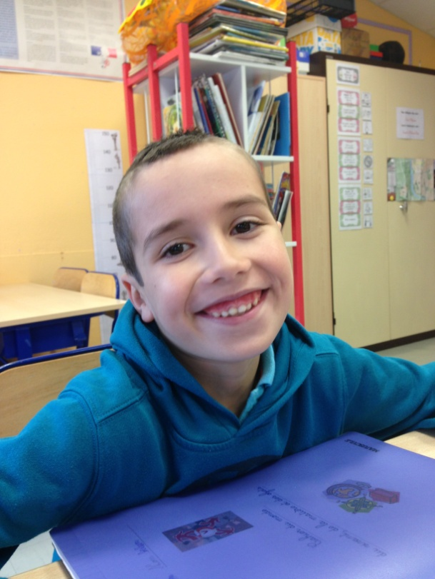
Hello!
My name is Pierre-Alexandre.
I’m 7 years old.
I live in Vichy, in France.
I have three sisters and no brother.
I have no dog and no cat and no rabbit.
I like playing tennis.
I don’t like going to the gym.

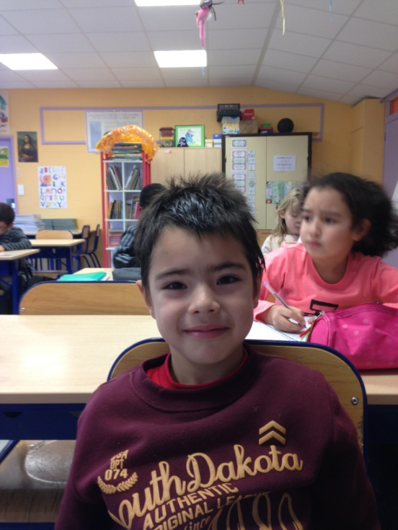
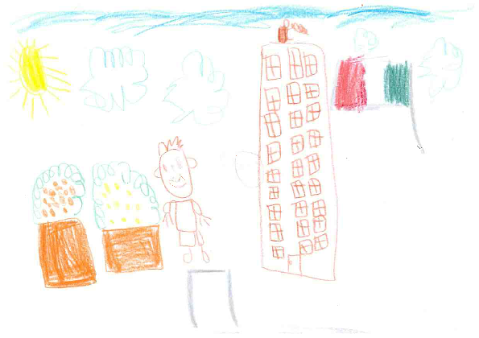
Hello!
My name is Enrique.
I’m 7 years old.
I live in Vichy, in France.
I have no sister and one brothers.
I have one dog but no cat and no rabbit.
I like sports.
I don’t like oranges.

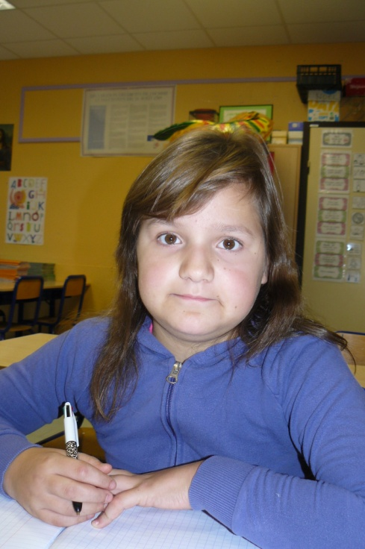
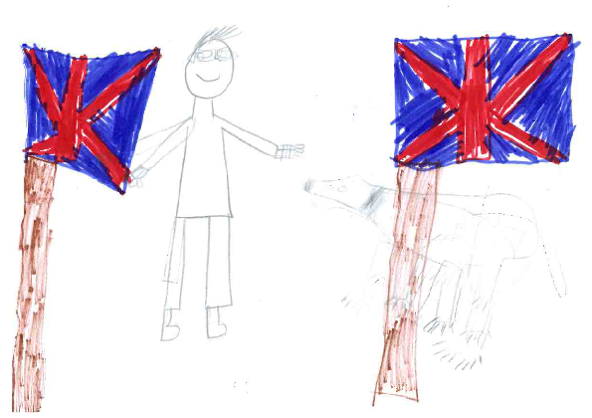
Hello!
My name is Lucie.
I’m 10 years old.
I live in Vichy, in France.
I have one sister and no brother.
I have no dog and no cat and no rabbit.
I like.
I don’t like.

